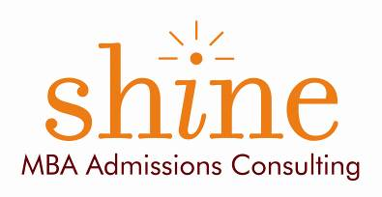

Looking to get into a top MBA program?

The Princeton Review is proud to host two free workshops
to give you an edge in the admissions process
and a personalized plan to get admitted to the schools of your choice

Join The Princeton Review
&
MBA admissions expert Hillary Schubach
President, Shine/ MBA Admissions Consulting
(Harvard MBA 2001)

for the insider tips and strategies to ensure your application stands out from the rest,
to reduce the stress and mystery surrounding the admissions process,
and to leave you with actionable tools and resources to help you get started.

Monday July 20th, Boulder

Attend any or all sessions:

GMAT Strategy Session  6:00 pm | MBA Admissions Strategy Session  7:00 pm
What we’ll cover:  - The structure of the GMAT  - Key GMAT strategies  - Sample quantitative and verbal questions | What we’ll cover:  - What the best schools are looking for  - School choice and how to narrow your options  - Securing the strongest recommendations  - Tips for writing the best essays  - Common application mistakes and how to avoid them  - Handling employment gaps and other concerns  - Nailing your interviews  - Your questions

Who should attend: Professionals, recent college graduates, and current students pursuing an advanced business career

Location: The Princeton Review, 1135 Broadway #200, Boulder, CO 80302, (303)939-9100

To register: Click here to register on The Princeton Review website

For more information: contact Ashley Czech at (303)939-9100 or ashleyc@review.com

GMAT is a registered trademark of the Association of the Graduate Management Admissions Council (GMAC). The Princeton Review is not affiliated with Princeton University.

